**MySQL-**

MySQL is currently the most popular database management system software used for managing the database.

It is open-source database software which is supported by Oracle Company.

It is fast, scalable and easy to use database management system.

For manipulating data, these queries are: insert records, update records, delete records, select records, create tables, drop tables, etc.

**Database**-

A database is an application that stores the organized collection of records.

It can be accessed and manage by the user very easily.

It allows us to organize data into tables, rows, columns, and indexes to find the relevant information very quickly.

Each database contains distinct [API](https://www.javatpoint.com/api-full-form) for performing database operations such as creating, managing, accessing, and searching the data it stores.

There are many databases available like MySQL, Sybase, Oracle, MongoDB, PostgreSQL, etc.

**How MySQL Works?**

MySQL follows the working of Client-Server Architecture.

This model is designed for the end-users called clients to access the resources from a central computer known as a server using network services.

Here, the clients make requests through a graphical user interface (GUI), and the server will give the desired output as soon as the instructions are matched.

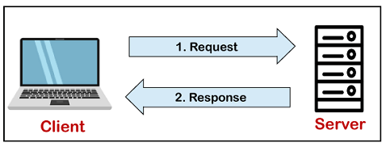

**Data Type in MYSQL-**

A Data Type specifies a particular type of data, like integer, floating points, Boolean, etc. It also identifies the possible values for that type, the operations that can be performed on that type, and the way the values of that type are stored. In MySQL, each database table has many columns and contains specific data types for each column.

**Clauses-**

1. Where- clause is used with SELECT, INSERT, UPDATE and DELETE clause to filter the results. It specifies a specific position where you have to do the operation.

Syntax- WHERE conditions;

Example- SELECT *  FROM student WHERE city = 'pune';

SELECT * FROM student WHERE city = ‘pune’  AND id < 5;

select * from student where salary>=25000 AND salary<=48000;

1. DISTINCT- clause is used to remove duplicate records from the table and fetch only the unique records. The DISTINCT clause is only used with the SELECT statement.

Syntax- SELECT DISTINCT expressions FROM tables [WHERE conditions];

Example- SELECT DISTINCT city FROM student;

1. FROM- clause is used to select some records from a table. It can also be used to retrieve records from multiple tables using JOIN condition.
2. ORDER BY- Clause is used to sort the records in ascending or descending order.

Syntax- SELECT expressions  FROM tables [WHERE conditions]  ORDER BY expression [ ASC | DESC ];

Example- SELECT * FROM student  WHERE city = 'pune' ORDER BY salary;

**MYSQL Key**

1. **Primary Key-**

MySQL primary key is used to identify each record in a table uniquely.

It cannot be null or empty.

It can contain only one primary key.

It always contains unique value into a column.

**Rules-**

1. The primary key column value must be unique.
2. Each table can contain only one primary key.
3. The primary key column cannot be null or empty.
4. **Foreign Key-**

The foreign key is used to link one or more than one table together. It is also known as the **referencing** key.

A foreign key matches the primary key field of another table. It means a foreign key field in one table refers to the primary key field of the other table.

**Aggregate function-**

* 1. MySQL count() function is used to returns the count of an expression. It allows us to count all rows or only some rows of the table that matches a specified condition.

mysql> SELECT COUNT(emp_name) FROM employees;

* 1. The MIN() & MAX() function in MySQL is used to return the **minimum value and maximum** in a set of values from the table.

mysql> SELECT MIN(income) AS Minimum_Income FROM employees;

**SQL Commands-**

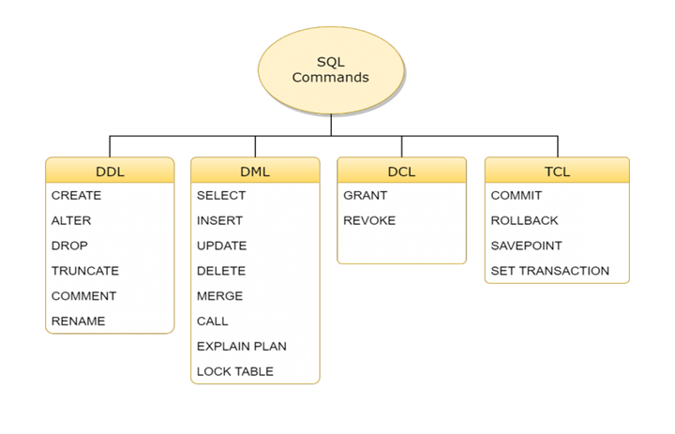

**DDL Statements-**

DDL is short name of Data Definition Language, which deals with database schemas and descriptions, of how the data should reside in the database.

* [CREATE](https://www.w3schools.in/mysql/php-mysql-create/) – used to create a database table
* ALTER - alters the structure of the existing database
* DROP - delete objects from the database.
* TRUNCATE - remove all records from a table, including all spaces allocated for the records are removed
* COMMENT - add comments to the data dictionary
* RENAME - rename an object.

**DML Statements-**

DML is short name of Data Manipulation Language which deals with data manipulation and includes most common SQL statements such SELECT, INSERT, UPDATE, DELETE, etc., and it is used to store, modify, retrieve, delete and update data in a database.

* [SELECT](https://www.w3schools.in/mysql/php-mysql-select/) - retrieve data from a database
* [INSERT](https://www.w3schools.in/mysql/php-mysql-insert/) - insert data into a table
* [UPDATE](https://www.w3schools.in/mysql/php-mysql-update/) - updates existing data within a table
* [DELETE](https://www.w3schools.in/mysql/php-mysql-delete/) - Delete all records from a database table
* MERGE - UPSERT operation (insert or update)
* CALL - call a PL/SQL or Java subprogram
* EXPLAIN PLAN - interpretation of the data access path
* LOCK TABLE - concurrency Control

**DCL Statements-**

DCL is short name of Data Control Language which includes commands such as GRANT and mostly concerned with rights, permissions and other controls of the database system.

* GRANT - allow users access privileges to the database
* REVOKE - withdraw users access privileges given by using the GRANT command

**TCL Statements-**

TCL is short name of Transaction Control Language which deals with a transaction within a database.

* COMMIT - commits a Transaction
* ROLLBACK - rollback a transaction in case of any error occurs
* SAVEPOINT - to rollback the transaction making points within groups
* SET TRANSACTION - specify characteristics of the transaction.

**MySQL-**

**Table create**

**Syntax-** CREATE TABLE table_name (column_name column_type);

**Example-**

CREATE TABLE User (

id int not null auto_increment,

LastName varchar(255),

FirstName varchar(255),

Address varchar(255),

City varchar(255),

Salary varchar(255),

primary key(id)

);

**Table insert-**

**Syntax-**

insert into table_name ( column1, column2,...columnN )VALUES(value1, value2,...valueN );

**Example**-

For single insert records-

insert into User (lastName,firstName,Address,City,Salary)values ('naik', 'jay', 'chinchwad','pune', 25000);

For multiple insert records-

insert into User (lastName,firstName,Address,City,Salary) values ('patil', 'ashok', 'pimpri','pune', 45000),('patil', 'ram', 'kothrud','pune', 35000);

**Table update-**

**Syntax**

UPDATE table_name SET column_name1 = new-value1, column_name2=new-value2, ... [WHERE Clause]

**Example**

update user set firstName = 'rohan' where lastName='kulkarni' //Single record or field

or

update user set firstName = 'rohan' where id=3

update employee set username = 'rohan', password='kulkarni' where id=1; //multiple field in same record.

update user set city = 'mumbai' where City='pune'; //updating multiple record for multiple user.

**Table delete**

**Syntax-**

DELETE FROM table_name WHERE condition;   //specific data delete

SET SQL_SAFE_UPDATES = 0;

delete from user; //it will delete the all the table data not structure

Example-

delete from user where id=3;

**Table select**

**Syntax**-

SELECT field_name1, field_name 2,... field_nameN FROM table_name1

[WHERE condition]

Example-

select * from user;

select * from user where city='pune'

Table Alter- (Add, Delete, Modify)

**Syntax-Add**

ALTER TABLE *table_name* ADD *column_name datatype*;

Example-

ALTER TABLE user   
ADD Email varchar(255);

**Syntax-Modify**

ALTER TABLE *table_name* MODIFY COLUMN *column_name datatype*;

Example-

ALTER TABLE user

modify Email varchar(125);

**Syntax-Drop**

ALTER TABLE *table_name* DROP COLUMN *column_name*;

Example-

ALTER TABLE user

drop Email;

**Difference between delete and truncate?**

| S.NO | Delete | Truncate |
| --- | --- | --- |
| 1. | The DELETE command is used to delete specified rows(one or more). | While this command is used to delete all the rows from a table. |
| 2. | It is a DML(Data Manipulation Language) command. | While it is a DDL(Data Definition Language) command. |
| 3. | There may be WHERE clause in DELETE command in order to filter the records. | While there may not be WHERE clause in TRUNCATE command. |
| 4. | In the DELETE command, a tuple is locked before removing it. | While in this command, data page is locked before removing the table data. |
| 5. | We can rollback the data even after using DELETE command. | While in this command, we can’t rollback. |
| 6. | DELETE command is slower than TRUNCATE command. | While TRUNCATE command is faster than DELETE command. |